BIOGRAPHY
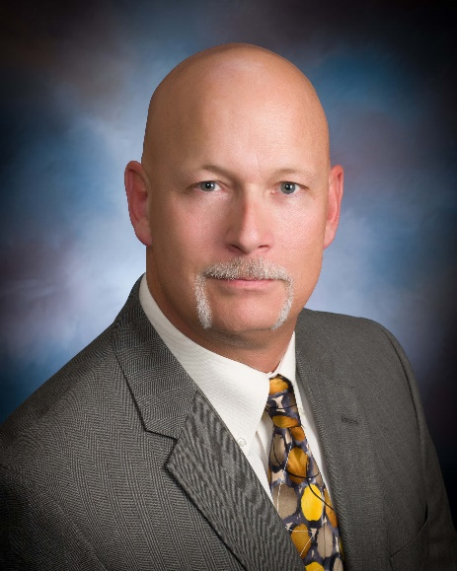
Greg Mellema, Ph.D. is an Assistant Professor at Embry-Riddle Aeronautical University teaching a variety of maintenance-related courses at both undergraduate and graduate levels. Additionally, he conducts research focused on advanced composites as well as maintenance human factors. He has been an active Airframe & Powerplant mechanic since 1988 and holds an Inspection Authorization (I.A.) from the FAA as well.
Dr. Mellema has over 30 years’ experience working on both manned and unmanned military and civilian aircraft with a special emphasis on manufacture and repair of advanced composite structures. During that time, he worked extensively with the U.S. Army’s Test and Evaluation Command and later founded the Army’s Advanced Composites Lab at Redstone Arsenal. There he designed and built prototype advanced composite parts as well as modernizing composite repair tools, processes and procedures across all Army aviation platforms.
Greg holds a B.S. degree in Professional Aeronautics, an M.S. in Aeronautical Science and a Ph.D. in Aviation from Embry-Riddle Aeronautical University. He is also a member of SAMPE, AMT Society, and holds certifications in composites/composite repair from both SAE and CertTEC.

